Cultural Committee report (July,2022-June,2023)
15th August,2022
75th Independence Day was celebrated in our college in the presence of our Principal, teachers, non-teaching staff, students and honourable personalities of our locality. It was organized in our college premise. The programme started with the inaugural song of our vocal team with music teacher and students followed by flag hoisting by our honourable principal sir and national anthem. Teachers and students of our college delivered their valuable speech about the importance of the day. The programme ended with different performances of our NSS students. The following students of our college participated in the cultural programme on that very day.
- Karima Sultana 2.Neha Parvin 3. Sudipa Karmakar 4.Nourin Sultana 5.Sreshtha Mondal 6.Sreya Mondal
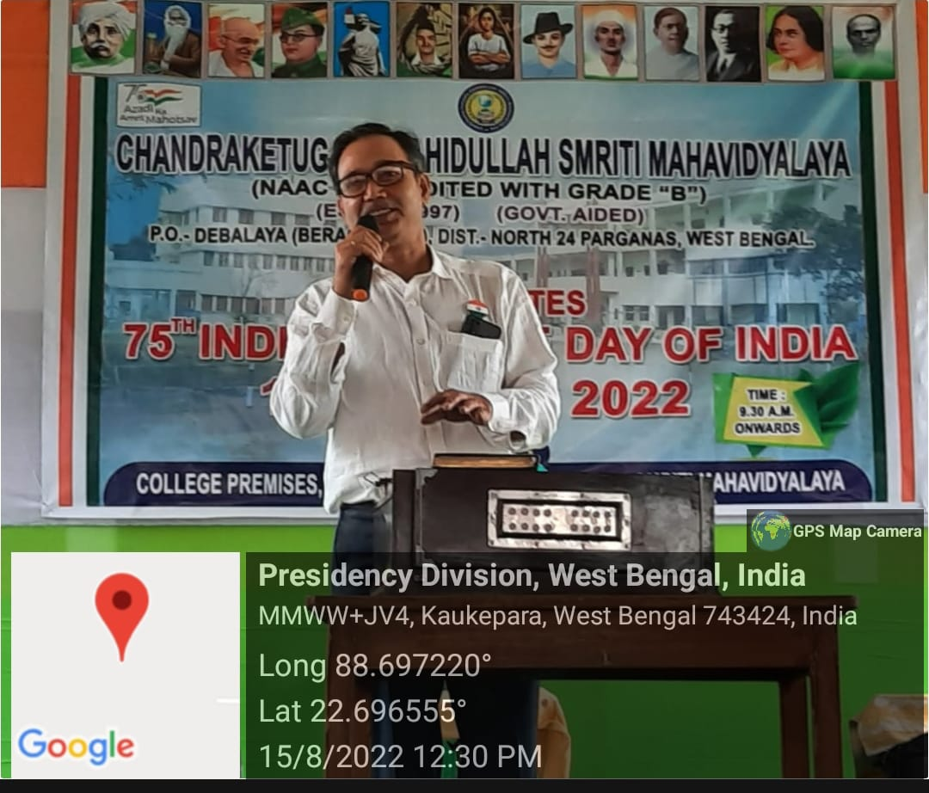

30th Sep, Sarat bandana
Every year, on the last day before puja vacation, we celebrate the spirit of festivity through a colourful cultural programme in our college, to welcome the ‘Sarat Ritu’, i.e, ‘Sarat Vandana’. This year also, all the staff and students of our institution celebrated this event with joy and happiness through their several performances, like, singing, dancing, elocution etc. Following students performed in different activities on that day:
- Puja Biswas 2.Neha Parvin 3.Nourin Sultana 4.Sudipa Karmakar 5.Sushmita Das
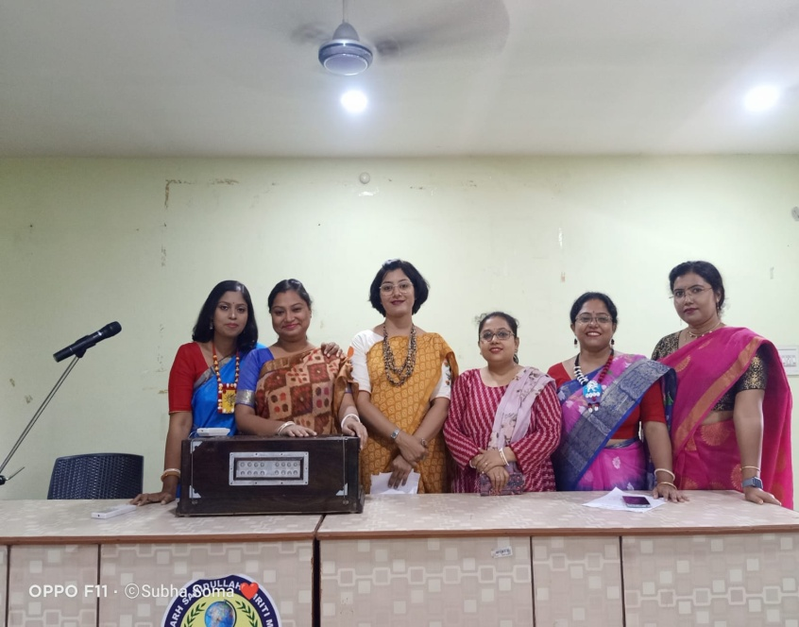
23rd Jan, 2023
On January 23, India paid its respects to freedom fighter Netaji Subhas Chandra Bose on the occasion of his birth anniversary. Like every year, this year also we celebrated ‘Netaji Jayanti’ to remember and honour Netaji's vigour as one of the greatest freedom fighters of India. We celebrated that day by garlanding his statue, hoisting the Indian national flag, and organizing cultural programs in our college. Our students sang patriotic songs and our respected principal sir delivered a speech on the importance of that day and motivated our students to follow the valuable principles of Netaji. The following students participated in the cultural programme of that day.
- Neha Parvin 2. Karima Sultana 3.Nourin Sultana 4.Sudipa Karmakar 5.Puja Biswas

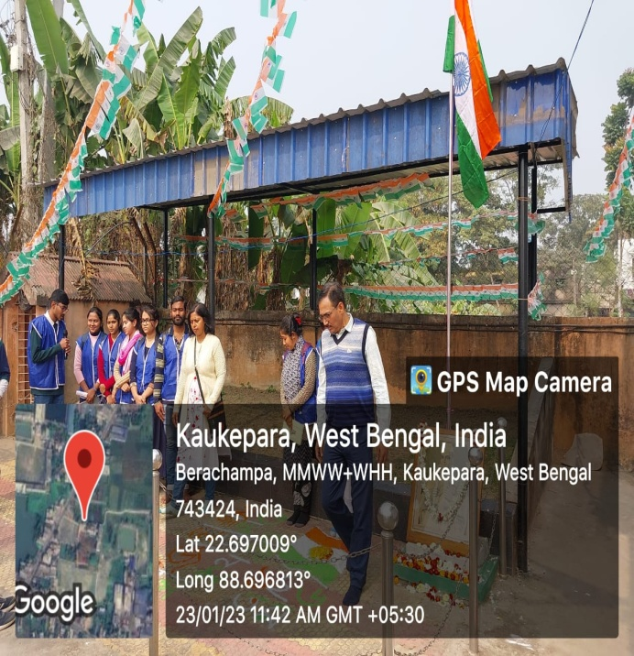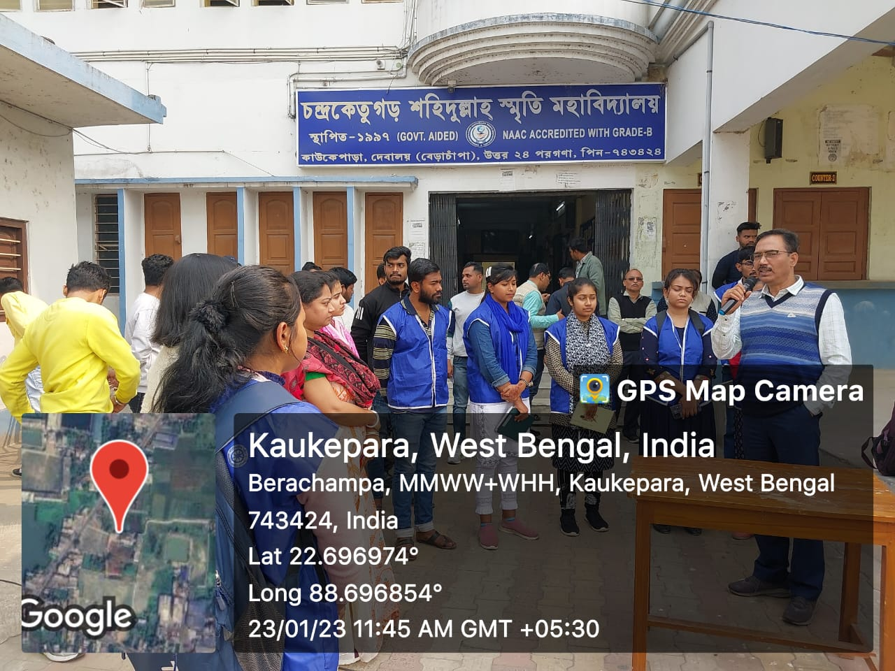
26th Jan, 2023
Republic Day in India observed on January 26th every year. The flag hoisting ceremony took place on the college grounds and we sang the national anthem with pride. Skits and dances became our medium to express the pride we felt for our nation as we commemorated the struggles and sacrifices that led to the birth of the largest democracy in the world.

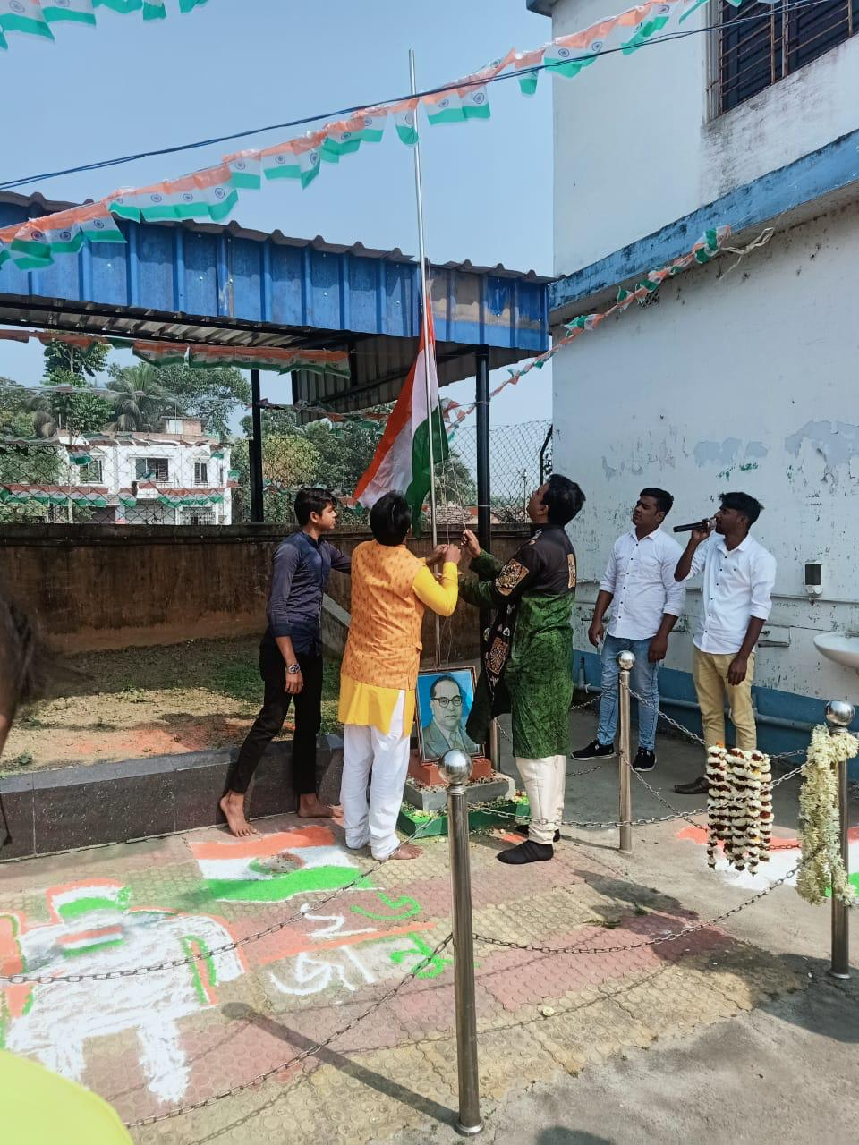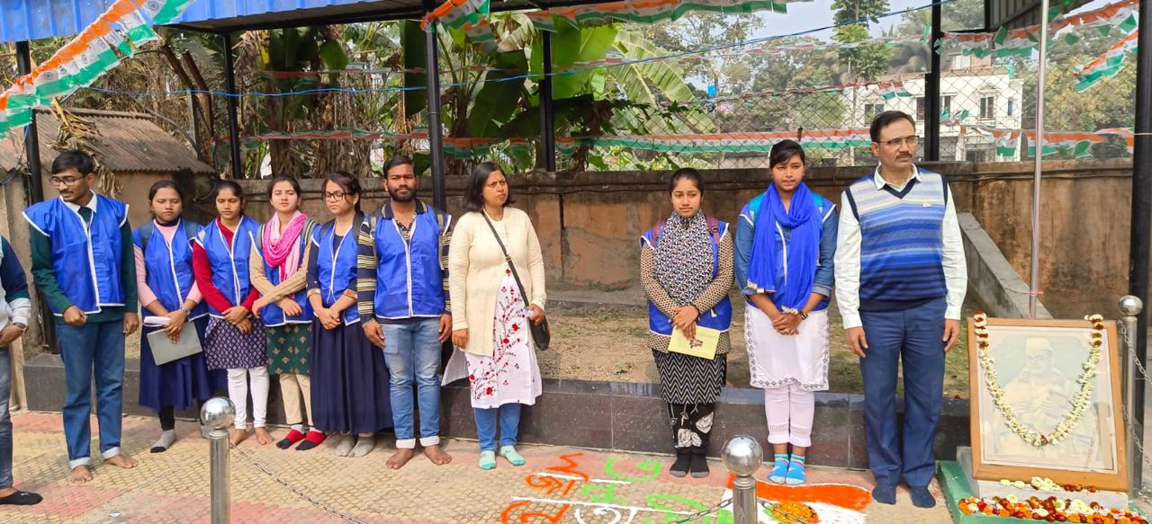

21st Feb, 2023

Every year we celebrate this programme to spread awareness of linguistic and cultural diversity, and to promote multi-lingualism.Then the main program was started in the seminar hall through the chorus song of our vocal music students and music teacher. Then the inaugural speech was given by our honourable principal Sir. Then a speech regarding the importance of the day-21st February was delivered by IQAC co-ordinator Dr. Saurabh Bhattacharya. After that our main cultural programme continued through different performances including dance, songs and recitations. The students participated are:

- Sreshtha Mondal 2.Sudipa Karmakar 3.Neha Parvin 4.Puja Biswas 5.Nourin Sultana 6.Karima Sultana

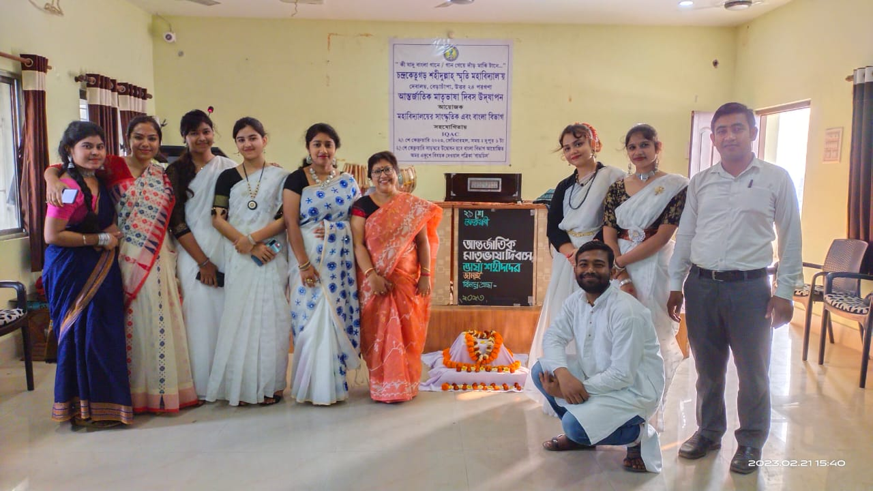

11th March,2023 Ritu bandana

Every year basanta Utsav is celebrated in our college just before the Dol Purnima. This year it was celebrated on 11th March,2023 at our seminar hall with the successful participation of our students, teachers and non-teaching staff. The following students performed in the programme.

- Puja Biswas 2.Nourin Sultana 3.Neha Parvin 4.Karima Sultana 5.Sreshtha Mondal 6.Sudipa Karmakar

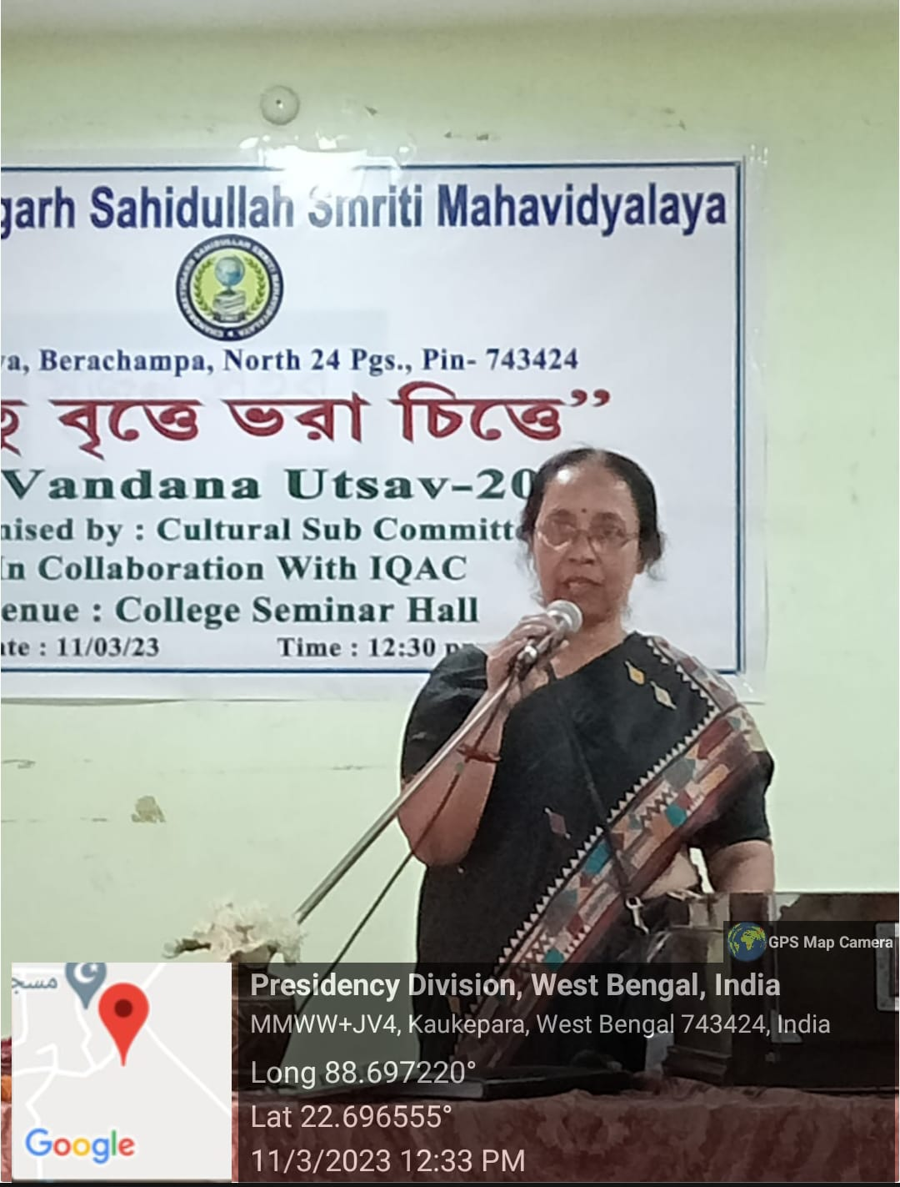

16-18 March, 2023 singing, dance, recitation competition
Three competition organized by cultural committee were held from 16th March to 18th March in the seminar hall of our college. The students of our college participated in various competitions and made the programme successful.

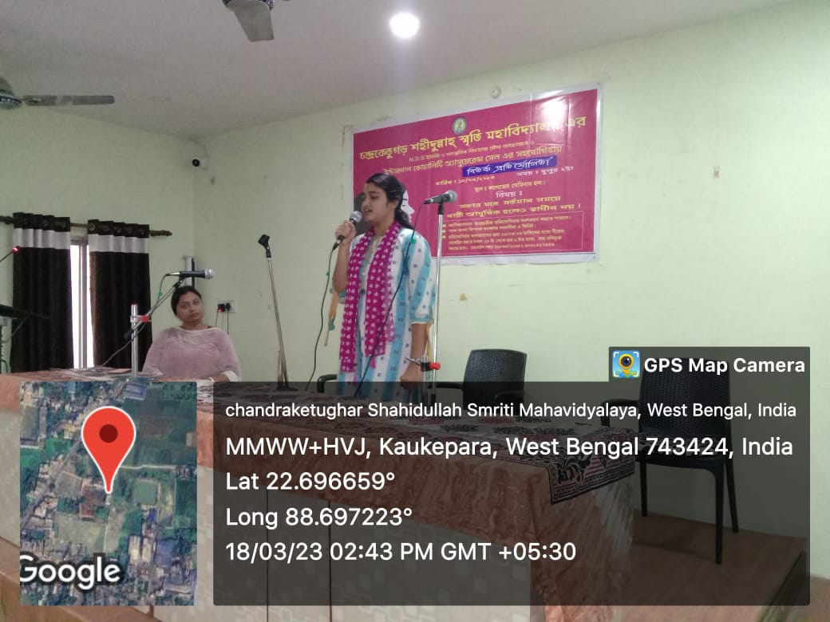

11 May, 2023 Rabindra Jayanti

Every year Rabindra Jayanti is celebrated by the students and staff of our college. This year also is it celebrated in our seminar hall in the presence of the students and staff and their various performance like Rabindra sangeet, dance, recitation dedicted to Kabi guru Rbindranath Tagore. The following students performed in the programme:

1.Sumon Manna 2.Sahina Sultana 3.Miraj Ahmed 4.Sudipa Karmakar 5.Neha Parvin 6.Nourin Sultana

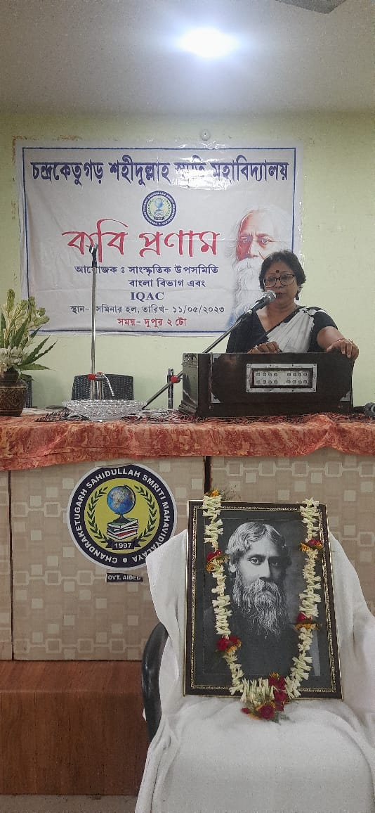

26th May, 2023 Najrul Jayanti
Like every year this year also we celebrated The birth day of Kazi Nazrul Islam in our college at the seminar hall in the presence of Principal sir, teaching and non-teaching staff and students. The following students performed in the programme.
- Puja Biswas 2.Neha Parvin 3 Nourin Sultana 4.Sudipa Karmakar 5.Miraj Ahmed 6.Sumon Manna

